# Documents for games data

* Games data documents encompass a wide array of information , player data reports, performance metrics, most_streamed_games viwes, average_stream_duration, language, most_active_day. Here are detailed descriptions of various types of game data documents:

Player Data Reports:

* **Player Data Reports:** Analyzes player behavior and engagement:
* **Demographics:** Age, gender, location, and other demographic information.
* **Usage Patterns:** Session length, frequency of play, and peak playing times.
* **Retention Metrics:** Daily Active Users (DAU), Monthly Active Users (MAU), churn rate.
* **In-game Behavior:** Popular levels, items, and in-game purchases.
* **most_streamed_games views:** To checked top 10 games playing for players like as gta v, League of Legends, Just Chatting,COD,racing, Counter-Strike etc.
* **most_active_day:** most playing games in weak

User Feedback:

* **Surveys and Questionnaires**: Player responses to structured questions about their experience.
* **Reviews and Ratings:** Analysis of reviews from app stores, forums, and social media.
* **Focus Group Reports**: Insights gathered from testing sessions with selected groups of players.
* inculding extra data steup for normalization data in games file

transfom_data 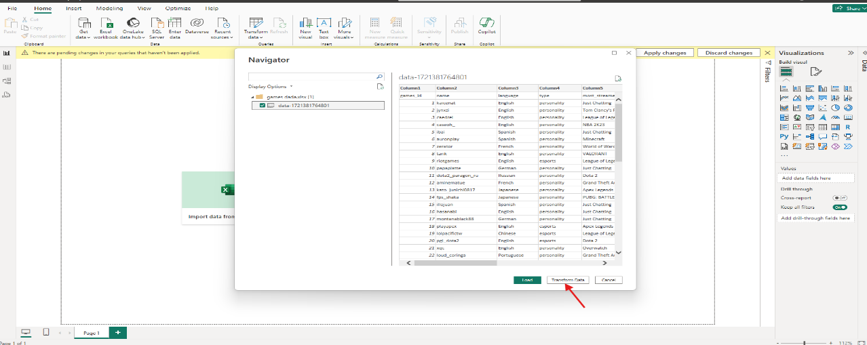

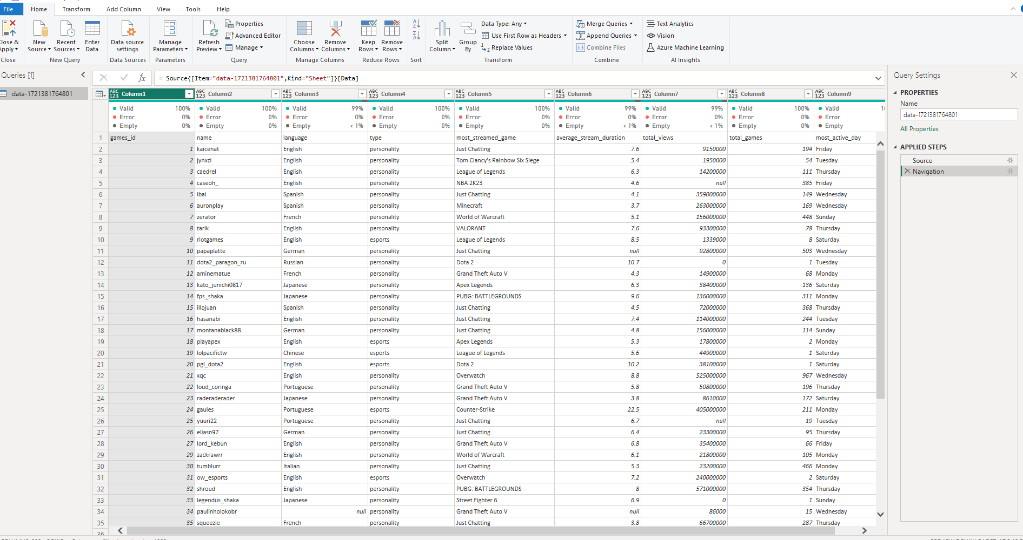

**STEP 2:** first click on use first row as header

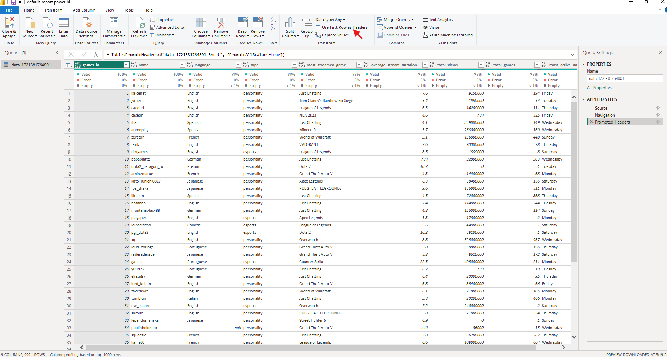

**STEP 3:** Checking first column and row any error ,null,blank data, and no data etc.

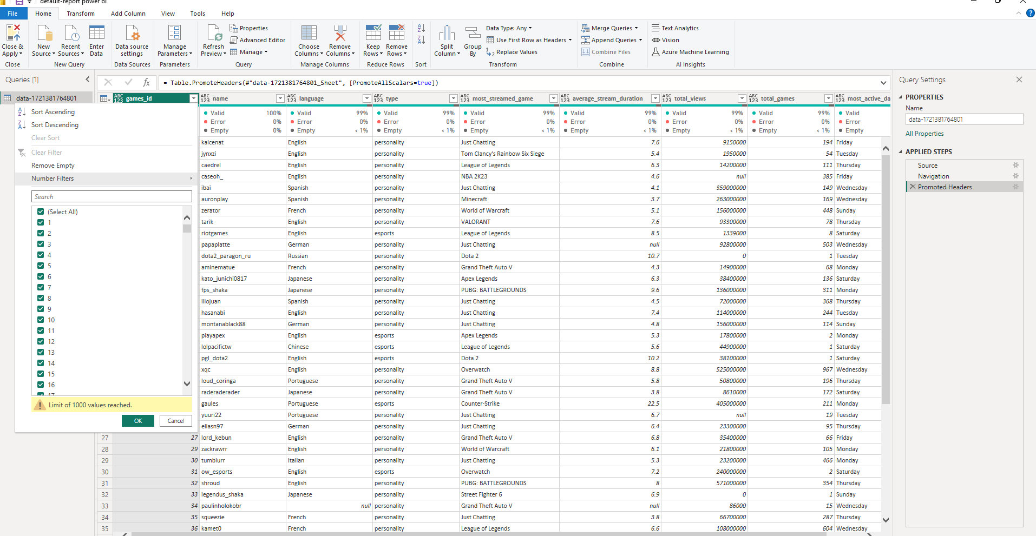

**STEP 4:** checking dcs i.e showing error ,null,blank data, and no data etc.

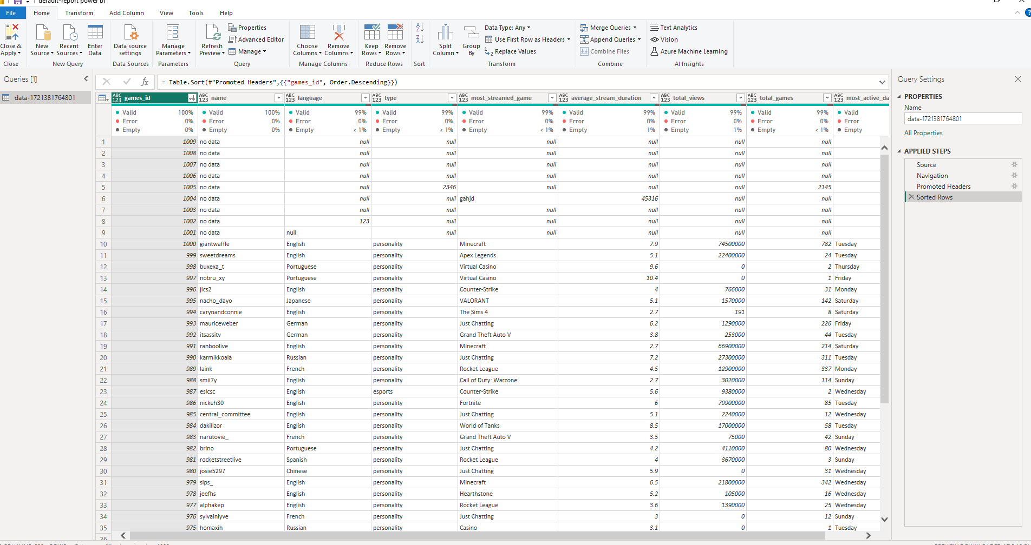

**STEP 5:** remove rows

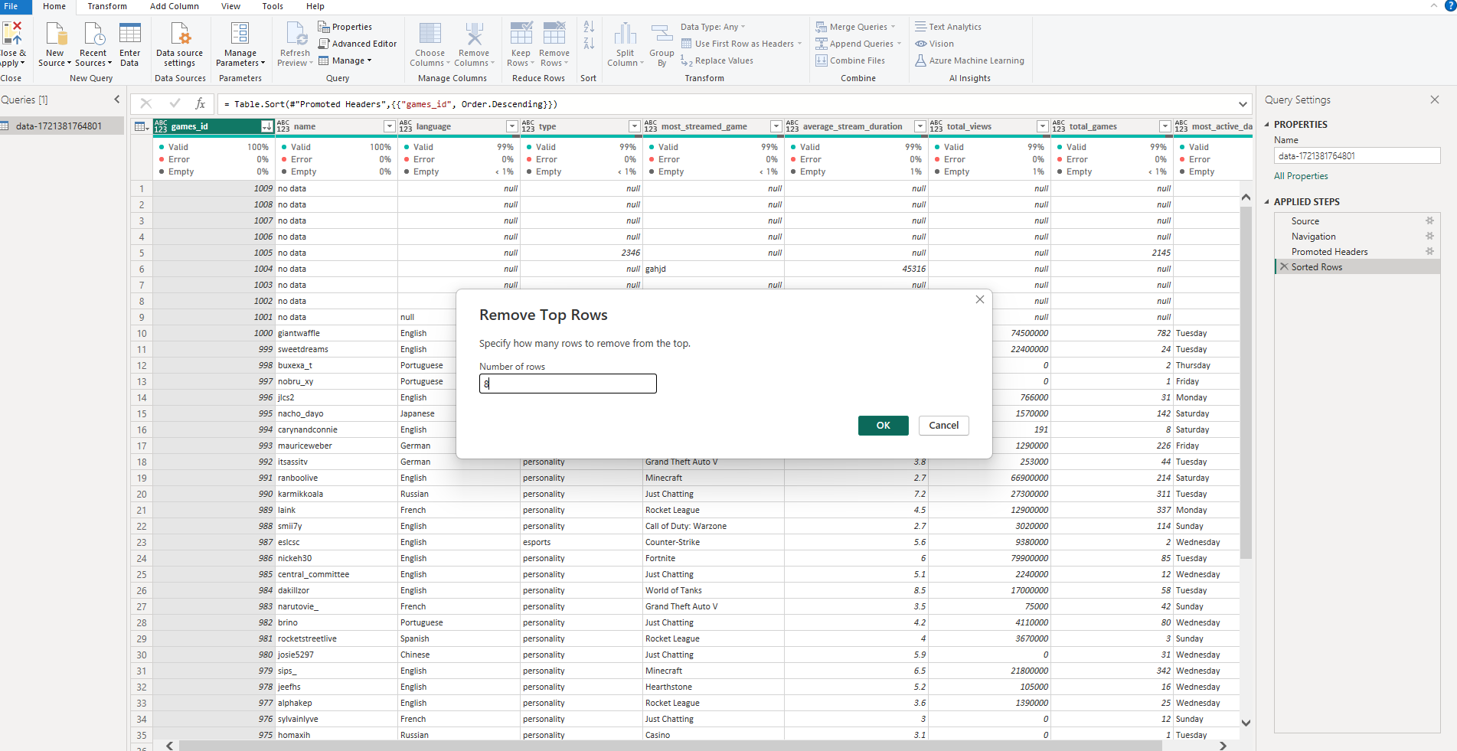

**STEP 6:** showing in languges different name it will be replaces

